 |  | NEASPEC/SOM(24)/3
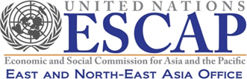 |  | Distr.: Limited  10 September 2020  English only

UNITED NATIONS
ECONOMIC AND SOCIAL COMMISSION FOR ASIA AND THE PACIFIC
Twenty-fourth Senior Officials Meeting (SOM) of NEASPEC
12-13 October 2020
Virtual

REVIEW OF PROGRAMME PLANNING AND IMPLEMENTATION
(Item 5(c) of the provisional agenda)
Marine Protected Areas

Note by the Secretariat

CONTENTS
I. BACKGROUND 2
II. PROGRESS AND FUTURE ACTIVITIES OF THE NEAMPAN 4
III. ISSUES FOR CONSIDERATION 7

Annex I. Draft report of study on sustainable management of marine protected areas
Annex II. Draft brochure of NEAMPAN sites

- BACKGROUND
- The North-East Asian Marine Protected Areas Network (NEAMPAN) was launched in November 2013 at the 18th Senior Officials Meeting (SOM-18) aiming to strengthen subregional cooperation on the marine environment. The Terms of Reference (TOR) of NEAMPAN adopted in SOM-18 spells out the objectives, scope of the network, and the operational framework of the network. Following the adoption of TOR, the Steering Committee was established, consisting of members and alternate members nominated from the member Governments.
- The national approaches to MPA, the strategic direction of the Network, target MPAs, network membership, as well as organizational and managerial structures of the Steering Committee were clarified at the 1st Steering Committee meeting held in March 2014 in Incheon, Republic of Korea (ROK). The Committee also agreed that target MPAs be nominated by respective governments through Steering Committee members. The TOR of the Steering Committee, endorsed by SOM-19 in 2014, defines the function of the Steering Committee as providing policy and operational guidance, planning and monitoring on NEAMPAN activities, as well as providing recommendations on new programmes and budgetary matters to SOM for consideration.
- The 1st NEAMPAN workshop was held back-to-back with the 2nd Steering Committee meeting in June 2016 at the Suncheon Bay Tidal Flat Wetland Protected Area, ROK, one of the target MPAs. The Workshop brought together Steering Committee members, managers of 8 NEAMPAN sites, as well as experts from international organizations and non-governmental organizations. The Workshop facilitated (1) sharing experiences of MPA management; (2) sharing experiences in partnership and networking among MPAs; and (3) exchanging views on common concerns and interests of the NEAMPAN members. Discussions included key protected species in each NEAMPAN site, challenges of insufficient funding, interests in eco-tourism balancing the conservation with socio-economic needs, and most importantly, areas of potential collaborative activities.
- Given that NEAMPAN sites are a collection of relatively well-managed MPAs under the national-level administration in respective countries, their monitoring and management experiences can provide insights on how to balance conservation and socio-economic objectives in MPA management. Studies on those experiences will serve as beneficial knowledge products for effective management of MPAs in member States. Thus, NEAMPAN Project on “Strengthening the subregional cooperation through knowledge sharing on sustainable management of marine protected areas”, proposed by the Russian Federation, was reviewed at the 2nd Steering Committee meeting. Consequently, the proposal was endorsed by SOM-21 in 2017, and funded by the Russian Federation for the implementation during 2018-2020.
- NEAMPAN currently has a total of 12 sites nominated by the member States, including six sites in China, one in Japan, three in the Republic of Korea, and two in the Russian Federation (shown in Table 1 below). Gochang Tidal Flat Wetland Protected Areas was added following the announcement of the nomination by the ROK at the SOM-22.
- The SOM-22 and SOM-23 encouraged the Democratic People’s Republic of Korea (DPRK) to join the activities of NEAMPAN, considering its participation in international fora on conservation. For example, the DPRK formally became the 170th Contracting Party to the Ramsar Convention and desginated the Mundok Migratory Bird Reserve and the Rason Migratory Bird Reserve as its first two “Ramsar Sites” in 2018; and also joined East Asian-Australasian Flyway Partnership (EAAFP) with Kumya Wetland Reserve and Mundok Wetland Reserve listed as Flyway Network Site (FNS) in 2018.
Table 1. NEAMPAN Sites
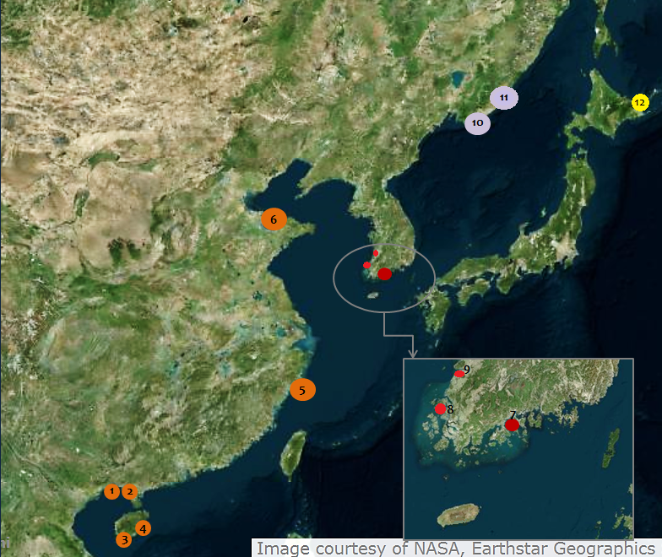
 | MPA site | Conservation status | Relevant international reference  (year of designation)
1 | (China) Beilun Estuary National Marine Nature Reserve | Marine Nature Reserve | Ramsar site (2008)
2 | (China) Shankou Mangrove National Marine Nature Reserve | Marine Nature Reserve | UNESCO-MAB Biosphere Reserve (2000); and Ramsar site (2002)
3 | (China) Sanya Coral Reef National Nature Reserve | Marine Nature Reserve
4 | (China) National Nature Reserve of Dazhou Island Marine Ecosystems | Marine Nature Reserve
5 | (China) Nanji Islands National Marine Nature Reserve | Marine Nature Reserve | UNESCO-MAB Biosphere Reserve (1998)
6 | (China) Changyi National Marine Ecology Special Protected Area | Marine Special Protected Area
7 | (ROK) Suncheon Bay Tidal Flat Wetland Protected Area | Coastal wetland protected area | Ramsar site (2006); and UNESCO-MAB Biosphere Reserve (2018)
8 | (ROK) Muan Tidal Flat Wetland Protected Area | Coastal wetland protected area | Ramsar site (2008)
9 | (ROK) Gochang Tidal Flat Wetland Protected Area | Coastal wetland protected area | Ramsar site (2010); UNESCO-MAB Biosphere Reserve (2013)
10 | (Russia) Far-Eastern State Marine Biosphere Reserve | State nature reserve | UNESCO-MAB Biosphere Reserve (2003)
11 | (Russia) Sikhote-Alin State Natural Biosphere Reserve | State nature reserve | UNESCO-MAB Biosphere Reserve (1978); and  UNESCO World Heritage Site (2001)
12 | (Japan) Shiretoko National Park | National park | UNESCO World Heritage Site (2005)

- PROGRESS AND FUTURE ACTIVITIES OF THE NEAMPAN
- NEAMPAN Workshop and the 3rd Steering Committee Meeting: NEAMPAN workshop and the 3rd Steering Committee Meeting were planned for 2020 in China. The Secretariat closely communicated with the focal points of NEAMPAN in the National Forestry and Grassland Administration (NFGA) and Ministry of Foreign Affairs, as well as Steering Committee members of China. As the NEAMPAN workshop expects interaction among the MPA managers as well as local stakeholders at one of the NEAMPAN sites, the Secretariat was of the view that workshop may be postponed until the time physical meeting is possible after the COVID-19 pandemic.
- In the meantime, an informal Steering Committee meeting was organized virtually on 24 June 2020, to update on the NEAMPAN programme and consult on future activities. The proposed activities include (a) collecting best practices from NEAMPAN sites, which can be utilized for national training and international workshops as reference; (b) organizing training or education programmes, including site visits, on the coordination and standardization of monitoring methodologies, management planning, scientific research, and anti-poaching; (c) establishing cooperation among NEAMPAN sites, especially those located in the same natural zones; (d) nominating additional NEAMPAN sites to expand coverage of the Network; and (e) encouraging more active participation of NEAMPAN in the work of other marine-related international organizations (e.g. NOWPAP, UNESCO MAB, PEMSEA, WESTPAC, etc.). In addition, members suggested the following areas of cooperation; experience sharing in balancing fishery activities and conservation in and around the NEAMPAN sites; experience sharing in eco-tourism; study on increasing marine biodiversity within the marine protected areas; and the evaluation of status on endangered marine species and ecologically important habitats for MPA designation.
- Strengthening the subregional cooperation through knowledge sharing on sustainable management of marine protected areas: Under the project, studies on MPAs of the four countries were conducted. The studies include review of modalities to assess environmental and socio-economic status of MPA and its connection to the management plans and strategies. In preparation of the studies, an Expert Meeting (of authors of the studies) on monitoring and assessment of MPAs were held in December 2018 in Incheon, Republic of Korea, (i) to review preliminary findings of the study to ensure coherence among the country studies and (ii) to identify MPAs for case studies. Follow-up meeting of the authors of the studies was held on 30 April 2019 in Incheon to provide feedback on the draft of the studies.
- The study revealed varying approach to MPA management in the studied countries. Purpose, scope, authorities responsible for planning and implementing management plans vary widely across the countries.
- In China, management plans of the Marine protected areas (MPAs), both Marine Nature Reserve (MNR) and Marine Special Protected Area (MSPA), are formulated following the general guidelines and revised regularly for approval by the central government. The approval of the plan is a precondition for the release of budget to the respective MPA management authority which is tasked to implement the management plan. The guideline of management plan includes sections to describe environmental as well as some aspects of socio-economic situation affecting the site. The Monitoring of the protected targets in all kinds of protected areas follows the technical guidelines on monitoring. Monitoring parameters include density and biomass of target species, sediment quality, water quality, etc. Monitored data are evaluated and analyzed and reflected into annual workplan to be implemented by the MPA administration, although the monitored data are not necessarily available for the public or research institutions.
- In Japan, MPA system is categorized in three groups by the administering ministries although they are not mutually exclusive. In the case of Shiretoko MPA, where fisheries activities are allowed, multiple administrative authorities are involved in the management depending on the target of protection, governed by respective legislation (e.g., fisheries by Fisheries Agencies; pollution control by Ministry of Environment, waste management by Ministry of Land, Infrastructure, Transport and Tourism). Long-term Management plan for the marine area of the Shiretoko National Park is unique as it was developed specifically to meet the commitment by the Government to meet the conditions for the inscription to the UNESCO World Natural Heritage List, to demonstrate the sustainable management (including fisheries) of the site. The Marine Management plan for the site details the monitoring plans and monitoring parameters responding to the plan, and the monitored data are reviewed and assessed by the working group regularly, while the data collection is mostly done by various authorities / institutions for different purposes and do not necessarily serve information needs of the site. Assessment of socio-economic impact on the site, as well as feedback mechanism for ecosystem monitoring results into plans or management measures are also weak.
- The Republic of Korea has 8 types of protected areas according to respective acts for management designated by three different ministries, i.e., Ministry of Oceans and Fisheries (MOF), Ministry of Environment, and Cultural Heritage Administration. Monitoring have been conducted with the national marine ecosystem monitoring program every year. Each of the three NEAMPAN has management master plan while environmental, while ecological / environmental monitoring is centralized at MOF which has jurisdiction over nationwide marine of our country. It operates survey systems such as National marine ecosystem monitoring, marine environment measurement network, automatic measuring network for marine water quality, fixed oceanographic survey, fishing ground environment monitoring, citizen monitoring, etc. for prompt diagnosis and evaluation of status and change of our country's marine ecosystem. In addition to ecological and environmental parameters, the national marine ecosystem monitoring program also includes socio-economic parameters such as economic valuation of tidal flat, residents’ awareness change.
- In the Russian Federation, there are various categories of specially protected areas (SPAs) such as reserves, national parks, nature monuments and zakanniks, depending on the strictness of protection, time frame, goal of establishment and level of management. However, sea areas are under federal jurisdiction in accordance with Russian legislation and thus there is no specific category or legislation for MPAs. The two NEAMPAN sites of Russia is under the category of Reserves where usually strict protection applies and the complete natural environment is to be conserved. Thus, no economic activity should be carried out in the territories of the protected areas, while the impact of regional and local economic systems is monitored to some extent according to the load level through the assessment of the input of pollutants with atmospheric precipitation and surface runoff. Development of policies and regulations, coordination and control of environmental monitoring is centralized in the Ministry of Natural Resources and Ecology, leaving limited role for the MPA management offices / institutions for monitoring the health of MPAs, except in the form of scientific research projects.
- The studies also indicated challenge in assessing the impact of and on socio-economic activities in and around the MPAs and linking it with MPA management plans and monitoring of ecological status.
- The Secretariat also planned to hold a workshop in conjunction with the project on “Strengthening the subregional cooperation through knowledge sharing on sustainable management of marine protected areas” in the ROK. The workshop was expected to share the project study findings and provide an opportunity for field visits to a NEAMPAN site, particularly for NEAMPAN site managers in other countries.
- As a part of the efforts to raise awareness and disseminate information on NEAMPAN among local stakeholders and public, the Secretariat prepared a brochure and profiles of the NEAMPAN sites (draft brochure is attached as Annex 2). The Secretariat plans to translate the brochure into local languages of the NEAMPAN members (Chinese/Japanese/Korean/Russian).
- Ocean issues at regional and global level: Importance of economic, social and environmental cooperation in ocean related issues is gaining ground in regional fora. ESCAP, at its 76th session of the Commission in 2020, highlighted ocean related issues as the key theme. It also highlighted ocean resources as key for sustainable development in its annual publication of Asia-Pacific Countries with Special Needs Development Report 2020. Consequently, the ESCAP member States adopted the Resolution 76/1 on “Strengthening cooperation to promote the conservation and sustainable use of the oceans, seas and marine resources for sustainable development in Asia and the Pacific” in 2020. The resolution, among others, calls on governments and stakeholders of member States to take urgent action for the conservation and sustainable use of oceans, seas and marine resources and share good practices and lessons learned. In this context, the NEAMPAN studies on MPAs in the North-East Asia can potentially demonstrate examples of area-based management for sustainable use of the ocean.

- ISSUES FOR CONSIDERATION
- In order to share challenges and opportunities in MPA management in various environment and socio-economic context, the Meeting may wish to encourage the member States to consider adding more NEAMPAN sites.
- In light of increasing emphasis on ocean related issues and management of marine resources for sustainable development at regional and global level, the Meeting may wish to request the member States to guide the Secretariat on future direction of NEAMPAN activities, in alignment with the NEASPEC Strategic Plan 2021-2025 in the medium term.
- While NEAMPAN is aimed at exchange of experiences and creating network among those involved in the management of MPAs, physical meetings are suspended due to the COVID-19 pandemic. In addition to some reformulation of planned activities reported above, the Meeting may wish to request the member States for further guidance on any new approach to achieve the objectives of NEAMPAN.
- The Meeting may wish to reiterete its encourgement for DPRK to participate in NEAMPAN activities, by nominating Steering Committee members, nominating MPA sites, and/or participating in the NEAMPAN workshops.
- The Meeting may wish to invite member States to propose NEAMPAN activities which are in line with the scope of the Network, as contained in the Terms of Reference, and to provide financial/in-kind contributions to activities.

………

ESCAP 76th Commission theme study entitled “Promoting economic, social and environmental cooperation on oceans for sustainable development” and the Asia-Pacific Countries with Special Needs Development Report 2020 entitled “Leveraging Ocean Resources for the Sustainable Development of Small Island Developing States”, https://www.unescap.org/commission/76/documents
ESCAP Resolution 76/1, https://www.unescap.org/commission/76/document/RES_76_1_ENG.pdf

